Hello, my name is **ACHINTYA BHATIA**,**2110990072,g5** and I’m a computer science student at **CHITKARA UNIVERSITY,PUNJAB**. I have experience with several programming languages, including [**Java**](https://leverageedu.com/blog/java-course/), [**Python**](https://leverageedu.com/discover/careers-in-india/how-to-become-a-python-developer/), and SQL. I’m particularly interested in artificial intelligence and machine learning, and I’m currently working on a project that involves developing an AI-powered bitcoin technology named as CYRUS.

Last semester, I worked on a team project that involved developing a mobile app for tracking fitness goals. I learned a lot about software development processes and project management during that experience.

After graduation, I hope to work as a software engineer at a tech company, where I can continue to develop my skills and contribute to innovative projects. In my free time, I enjoy attending hackathons and learning about new technologies in the field.

Well recently I have been working on a project given to me by my professor for the assessment

Basically it is a revolutionary parking reservation service that allows users to pre-book parking spaces in colleges and universities, ensuring a hassle-free parking experience and it is named as C Park.

Well I am choosing this project for the privacy, needs of the users.

The Snapshots of the projects are as follows:-

**HOME PAGE:-**

Prepared by: ACHINTYA BHATIA

Executive Summary: C Park is a revolutionary parking reservation service that allows users to pre-book parking spaces in colleges and universities, ensuring a hassle-free parking experience.

I. Key Metrics and Analytics:

1. Traffic Overview:

• Total visits - NA

• Unique visitors - NA

• Bounce rate - NA

• Time on page-NA

• Conversion rate (if applicable)-NA

2. User Demographics:

• Age-ANY

• Gender-ALL

• Location-INDIA

3. Traffic Sources:

• Organic search-20%

• Direct traffic-NA

• Referral sources-NA

• Social media-@achintya_bhatia

II. Design and User Experience:

1. Visual Design:

• Viewing pleasure good

• use of images, videos, and graphics.

2. Navigation:

• usability navigation menu.

• reformed menu items.

3. Mobile Responsiveness:

4. NO

5. Page Load Speed:

• 3 sec

• Suggest improvements if the load speed is slow. – in progress

III. Content Assessment:

1. Headline and Messaging:

• Assess the effectiveness of the headline and subheadings.

• Ensure that the messaging is clear and aligned with the website's purpose.

2. Value Proposition:

• Evaluate how well the home page communicates the website's value proposition.

• Suggest improvements to make it more compelling.

3. Calls to Action (CTAs):

• Analyze the placement and effectiveness of CTAs.

• Assess whether CTAs are leading visitors to desired actions.

IV. SEO and Search Performance:

1. Keyword Rankings:

• Check the current rankings for target keywords.

• Suggest keyword optimization strategies.

2. Meta Tags and Descriptions:

• Review the meta title and meta description for SEO optimization.

• Ensure they are relevant and compelling.

V. Social Media Integration:

1. Social Sharing and Follow Buttons:

• Evaluate the integration of social sharing buttons and follow buttons.

• Assess their effectiveness in increasing social engagement.

VI. Recommendations and Next Steps: Summarize the key recommendations based on the assessment and analysis in the report. Provide a clear action plan for improving the home page's performance and user experience.

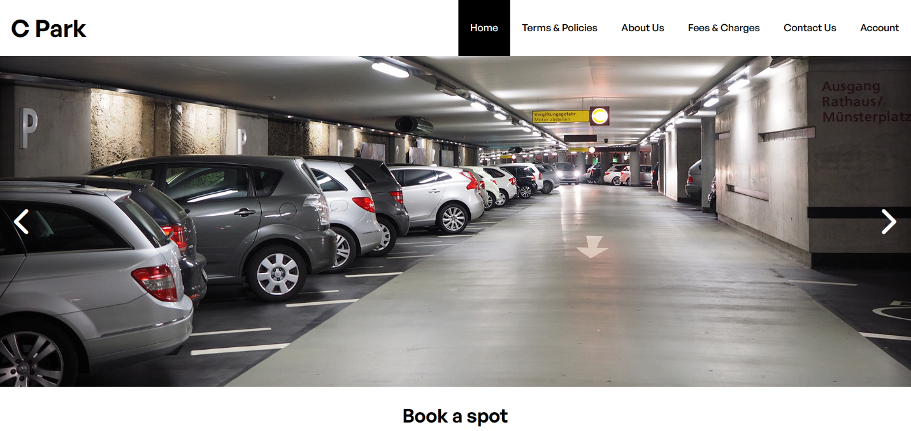 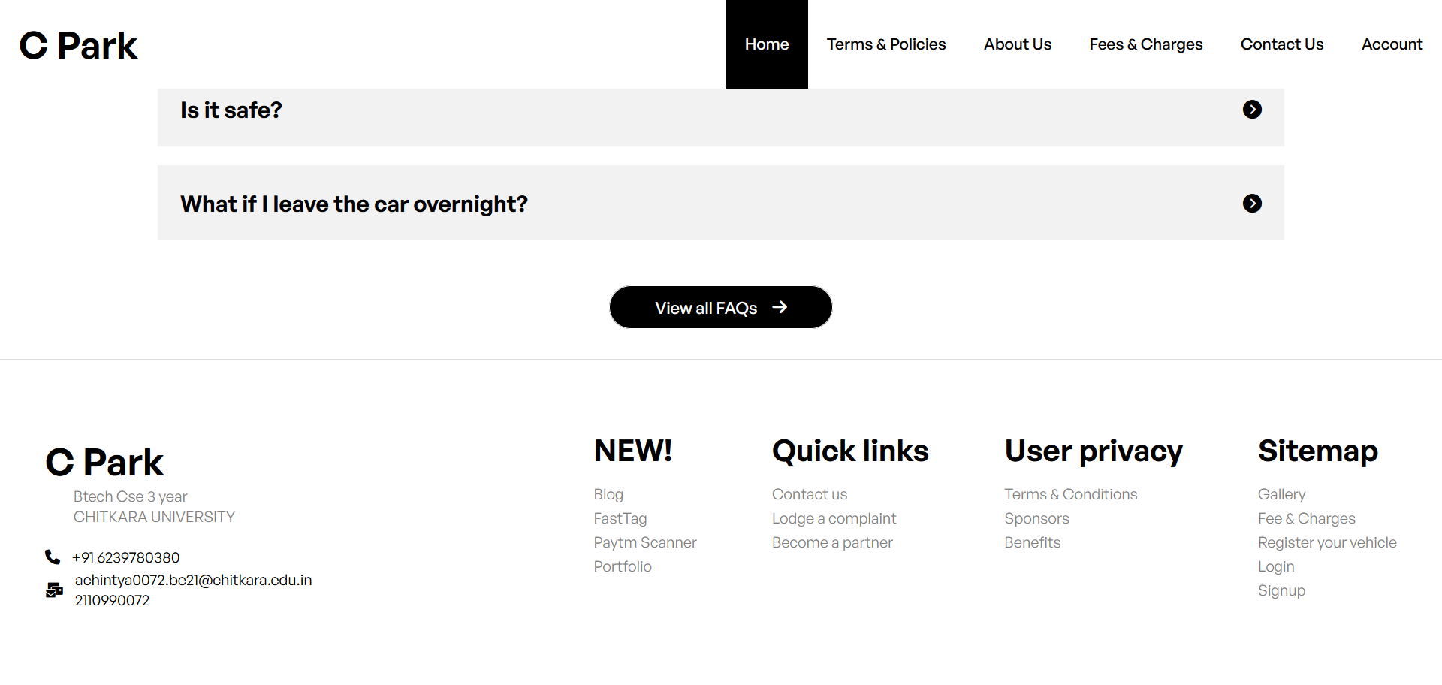

**TERMS AND CONDITIONS:-**

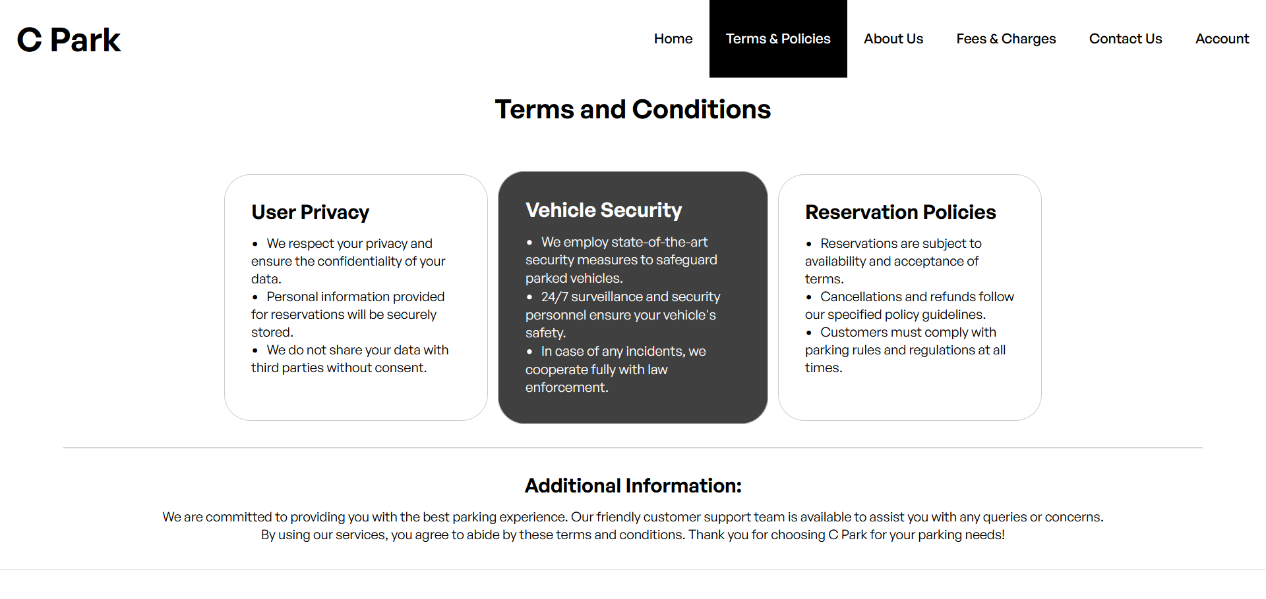

I. Compliance Assessment:

1. Legal Compliance:

• Ensure that your T&C page complies with relevant laws and regulations, such as GDPR, CCPA, or other regional data privacy laws.

2. Accessibility:

• Confirm that the T&C page is accessible to all users, including those with disabilities, in accordance with accessibility guidelines like WCAG.

II. Content Review:

1. Clarity and Understandability:

• Assess the clarity of the language used in the terms. Are they easily understood by the average user?

2. Comprehensiveness:

• Ensure that all necessary terms and clauses are included, such as disclaimers, liability limitations, intellectual property rights, and user obligations.

3. Updates and Amendments:

• Review the process for updating and amending the terms. Ensure that it is clearly defined.

4. Termination and Suspension:

• Review any provisions related to account termination, suspension, or user rights in case of a breach of terms.

III. User Acknowledgment and Consent:

1. Consent Mechanisms:

• Assess how users are required to acknowledge and agree to the terms.

• Ensure that there are clear and active consent mechanisms (e.g., checkboxes or "I Agree" buttons).

2. Consent Records:

• Check if consent records are maintained and accessible for verification if needed.

IV. Data Privacy and Security:

1. Data Collection and Usage:

• Review how user data is collected, stored, and used. Ensure it aligns with your Privacy Policy and relevant regulations.

2. Security Measures:

• Confirm that the T&C page mentions security measures in place to protect user data.

V. Dispute Resolution and Governing Law:

1. Dispute Resolution Process:

• Review any provisions regarding dispute resolution mechanisms (e.g., arbitration or mediation).

2. Choice of Law:

• Verify that the governing law under which disputes are resolved is specified.

VI. User Education:

1. Accessibility:

• Evaluate whether users can easily find and access the T&C page.

• Check if there are links to the T&C page in prominent areas of your website.

2. Plain Language Summary:

• Consider providing a plain language summary or FAQ section to help users understand key terms.

VII. Recommendations and Next Steps: Summarize the key recommendations based on the assessment and analysis in the report. Provide a clear action plan for improving the T&C page's compliance and user-friendliness.

**ABOUT US:-**

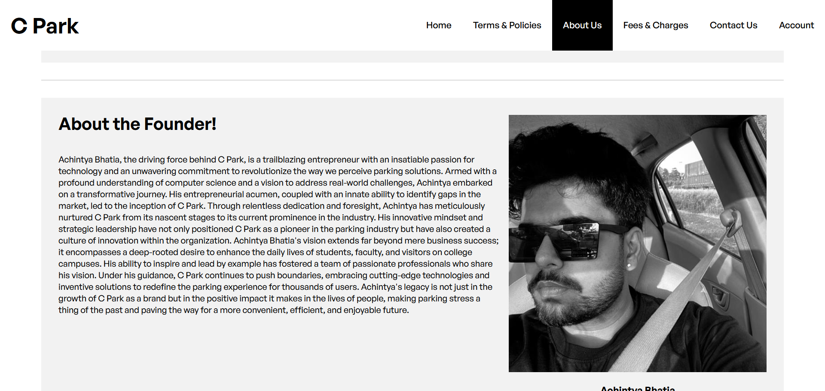

I. Content Assessment:

1. Clarity and Relevance:

• Assess the clarity of the language and the relevance of the information provided on the About Page. Is the message clear and compelling?

2. Mission and Values:

• Review the articulation of the website's mission, vision, and core values. Are these clearly communicated?

3. History and Background:

• Evaluate the presentation of the website's history, background, and the team behind it.

4. Testimonials or Success Stories:

• Check for the inclusion of testimonials, success stories, or case studies that build credibility.

5. Visual and Multimedia Content:

• Evaluate the use of images, videos, or other multimedia content to enhance the page's visual appeal.

II. User Engagement:

1. Call to Action (CTA):

• Assess whether the About Page encourages visitors to take specific actions, such as exploring other sections of the website or subscribing.

2. Interactivity:

• Review if there are interactive elements, such as links to social media profiles, contact forms, or chat support.

III. Brand Consistency:

1. Visual Branding:

• Ensure that the visual elements on the About Page, including logos and color schemes, align with the overall brand identity.

2. Tone and Messaging:

• Confirm that the tone and messaging used on the About Page are consistent with the brand's voice and style.

IV. SEO and Keywords:

1. Keyword Relevance:

• Evaluate the use of relevant keywords on the About Page to improve its search engine visibility.

2. Meta Tags and Descriptions:

• Review the meta title and meta description for SEO optimization.

V. User Navigation:

1. Accessibility:

• Check if users can easily find and access the About Page.

• Assess whether there are links or navigation elements leading to the About Page.

VI. Recommendations and Next Steps: Summarize the key recommendations based on the assessment and analysis in the report. Provide a clear action plan for enhancing the About Page's content and user engagement.

**FEES AND CHARGES:-**

**I**

**VII. Recommendations and Next Steps:** Summarize the key recommendations based on the assessment and analysis in the report. Provide a clear action plan for improving DATA.

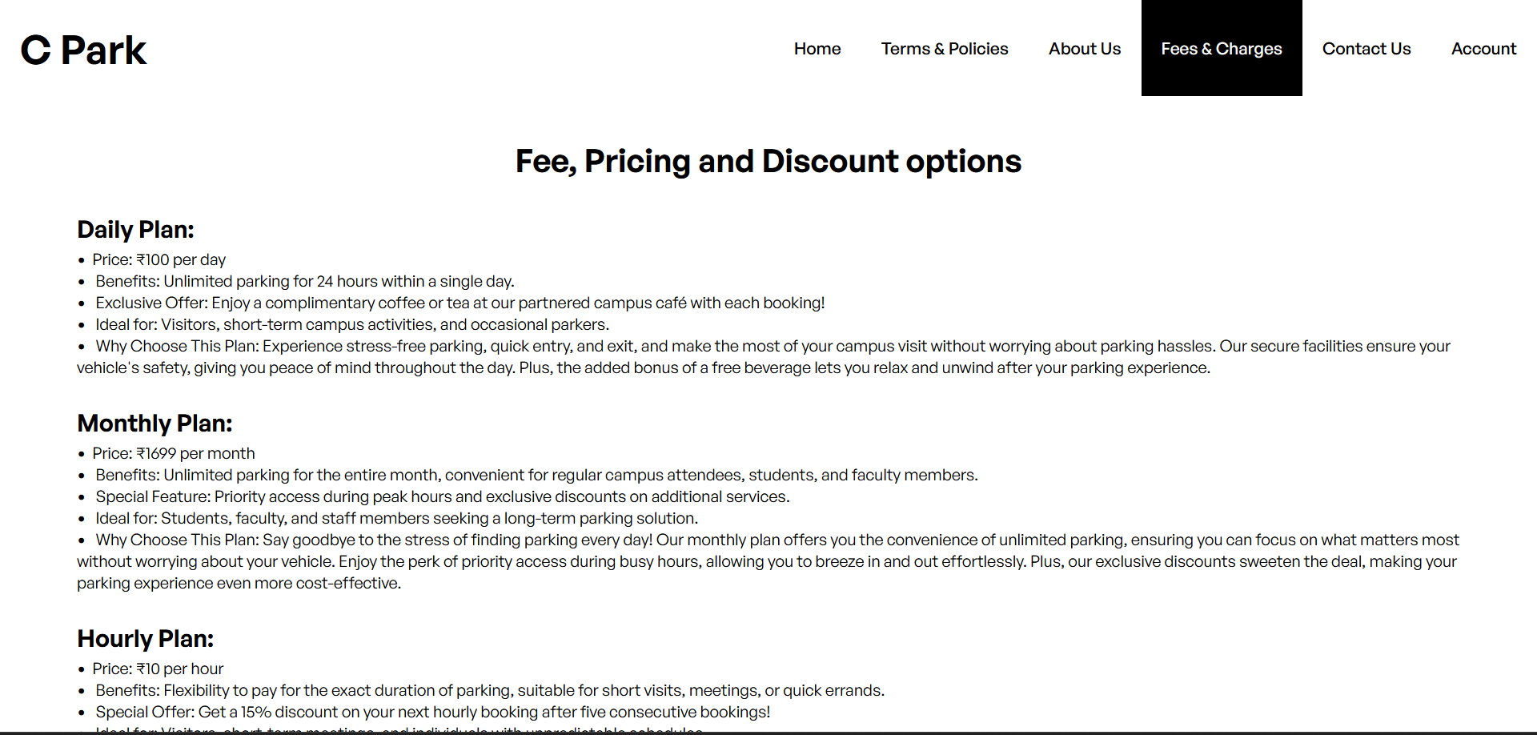

Fee Structure and Details:

1. Service/Product Categories:

• List and categorize the services or products offered on the website for which fees and charges apply.

2. Fee Types:

• Specify the different types of fees, such as subscription fees, transaction fees, one-time charges, or any other relevant categories.

3. Pricing:

• Detail the specific fees associated with each service or product. Include pricing tiers, if applicable.

4. Payment Methods:

• Explain the accepted payment methods for the fees, including credit cards, PayPal, and any other options.

II. Transparency and Disclosure:

1. Clear Explanation:

• Assess the clarity and comprehensibility of the fee explanations. Are users able to easily understand what they're being charged for?

2. Timing of Charges:

• Clarify when and how charges are applied (e.g., monthly, annually, per transaction).

3. Currency and Conversion Rates:

• If applicable, specify the currency used for fees and charges, as well as any conversion rates for international users.

III. Discounts and Promotions:

1. Discounts:

• Outline any available discounts, promotional codes, or special offers for users.

2. Terms and Conditions:

• Describe the terms and conditions that apply to these discounts, including eligibility and expiration dates.

IV. Refund and Cancellation Policies:

1. Refunds:

• Explain the website's refund policy, including conditions under which refunds are provided.

2. Cancellations:

• Clarify the process for canceling subscriptions or services, and any associated fees.

V. Communication and Notifications:

1. User Notifications:

• Describe how users are informed about fees and charges, both prior to purchase and during use.

2. Updates and Changes:

• Explain how users are notified about changes to fees and charges and the frequency of such notifications.

VI. Compliance and Legal Considerations:

1. Regulatory Compliance:

• Ensure that the fees and charges comply with relevant laws and regulations, such as consumer protection and pricing transparency laws.

2. Terms and Conditions Alignment:

• Confirm that the fees and charges align with the terms and conditions outlined in your legal agreements.

**Contact us:-**

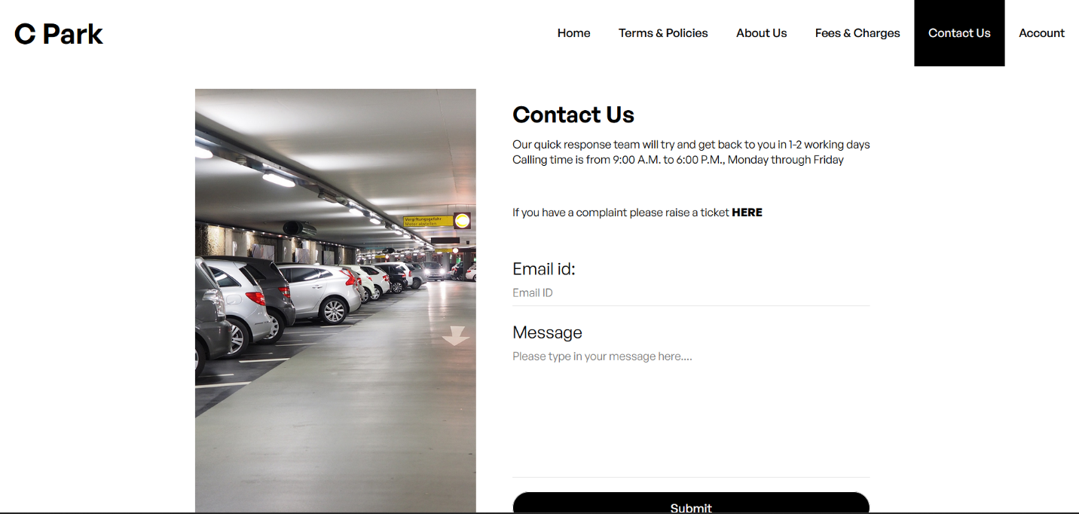

I. Contact Information:

1. Address and Location:

• Confirm that the physical or mailing address is accurate and up to date, including any additional location details (if applicable).

2. Phone Number:

• Ensure that the phone number is current and functional. Include any regional or international dialing codes.

3. Email Address:

• Verify that the email address provided is monitored and operational for user inquiries.

II. Contact Form:

1. Form Fields:

• Evaluate the fields in the contact form. Are they clear and relevant for user inquiries?

2. User Experience:

• Test the usability of the contact form, including its responsiveness on different devices.

3. Response Time Commitment:

• Describe the expected response time to user inquiries submitted via the contact form.

III. Live Chat or Support Channels:

1. Availability:

• Confirm the availability of live chat or other support channels and their operating hours.

2. Response Times:

• Describe the expected response times for live chat or other support channels.

IV. Social Media Links:

1. Social Media Profiles:

• Ensure that links to your website's official social media profiles are provided and functioning.

2. Response on Social Media:

• Assess the website's responsiveness to user inquiries or feedback received through social media channels.

V. User Engagement:

1. Call to Action (CTA):

• Review whether the Contact Us Page encourages visitors to reach out for inquiries, feedback, or support.

2. User-Friendly Language:

• Evaluate the use of user-friendly and welcoming language to encourage communication.

VI. Accessibility:

1. Navigation:

• Check if users can easily find and access the Contact Us Page.

2. Multilingual Support:

• If applicable, ensure that the page supports multiple languages or offers translation options.

VII. User Education:

1. FAQ Section:

• Consider the inclusion of a Frequently Asked Questions (FAQ) section to address common inquiries.

VIII. Recommendations and Next Steps: Summarize the key recommendations based on the assessment and analysis in the report. Provide a clear action plan for improving user communication and responsiveness.

**Log in :-**

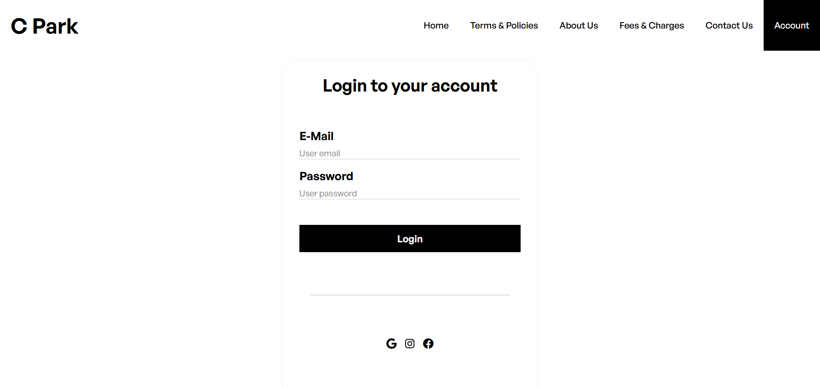

I. Security Assessment:

1. Authentication Mechanisms:

• Review the methods of user authentication (e.g., username and password, social media login, multi-factor authentication).

2. Password Policies:

• Evaluate password requirements, such as complexity, length, and expiration.

3. Account Lockout:

• Check for account lockout mechanisms to prevent brute force attacks.

II. User Experience:

1. User-Friendly Design:

• Assess the design and layout of the Log In Page. Is it user-friendly and responsive on various devices?

2. Remember Me Option:

• Confirm if there is an option for users to stay logged in for convenience.

3. Password Recovery:

• Review the password recovery process and its effectiveness for users who forget their passwords.

III. Error Handling:

1. Clear Error Messages:

• Evaluate the clarity of error messages when users enter incorrect credentials.

2. Security Notifications:

• Ensure that users are notified of login attempts and changes to their accounts, enhancing security.

IV. User Education:

1. Helpful Tips or Resources:

• Assess whether the Log In Page provides helpful tips or links to resources for users experiencing login issues.

V. Accessibility:

1. Navigation:

• Check if users can easily find and access the Log In Page.

2. Accessibility Compliance:

• Ensure that the Log In Page complies with accessibility standards for users with disabilities.

VI. Compliance and Legal Considerations:

1. Privacy and Data Protection:

• Confirm that the Log In Page complies with relevant data protection laws and regulations.

2. Terms and Conditions:

• Ensure that users have access to the terms and conditions that apply to their use of the website.

VII. Recommendations and Next Steps: Summarize the key recommendations based on the assessment and analysis in the report. Provide a clear action plan for improving security and user experience on the Log In Page.

**Well these are the main pages and it is only a trailer for more info must visit our website**

[**www.cpark.in**](http://www.cpark.in)

**It took me 1 month to complete the project also I faced many challenges in this journey sometimes I get confused in the codes and sometimes I forgot,through all these challenges I overcame and made a beautiful website for the users.**

For us user is the king and we value our users more than anything 😊

**Some more snapshots**



**THANK YOU ☺**